**THE FUTURE OF TECHNOLOGY**

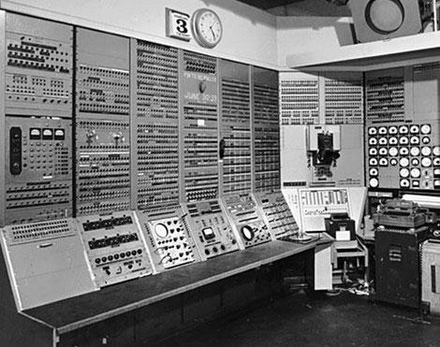

**Over 65 years ago, the world's first computer was “born”. Scientists called it “The Baby”, but it was huge. It filled an entire room! three people made the computer and programmed math problems for it. On June 19, 1948, the computer solved its first math problem - in 52 minutes! at that time, this was amazing.**

**Computers are now much smaller. With touch-screen technology, many computers don't need extra things, like a keyboard or a mouse. In the future, computers probably won't need the best things at all. Some computers, like the smartphone, can fit in one hand. Computers are also more powerful today. There is more computing power in a smartphone than there was in all of the computers on Apollo 11, the first spacecraft to take people to the moon!**

**How else will computers change in the future? A computer's “brain” is a chip inside the computer, and in the future, people will definitely be able to save much more information on a computer chip. so, computers will be smaller and even more powerful. Perhaps they will even think like humans! maybe we won't need to tell computers what to do because they will decide for themselves!**

Pregunta **1**

Correcta

Se puntúa 1.25 sobre 1.25

Marcar pregunta

Enunciado de la pregunta

**the first computer fit in _________**



a.

**A hand**



b.

**A building**



c.

**A room**

Pregunta **2**

Correcta

Se puntúa 1.25 sobre 1.25

Marcar pregunta

Enunciado de la pregunta

**The baby found the answer to ________ math problem(s) in 52 minutes**



a.

**65**



b.

**1**



c.

**3**

Pregunta **3**

Correcta

Se puntúa 1.25 sobre 1.25

Marcar pregunta

Enunciado de la pregunta

**The computers on Apollo 11 were _________ a smart phone**



a.

**More powerful than**



b.

**As powerful as**



c.

**Less powerful than**

Pregunta **4**

Correcta

Se puntúa 1.25 sobre 1.25

Marcar pregunta

Enunciado de la pregunta

**Today, many computers don't have __________.**



a.

**Touch screen**



b.

**Keyboards**



c.

**Chips**